Republic of the Philippines

Region III

Province of Pampanga

Municipality of Apalit

**BARANGAY PALIGUI**

*Office of the Sangguniang Kabataan*

**AN EXCERPT FROM THE MINUTES OF THE MEETING DURING THE 10th SANGGUNIANG KABATAAN REGULAR SESSION HELD ON October 5th 2024,**

**5:00 P.M. AT BARANGAY PALIGUI SESSION HALL, APALIT, PAMPANGA.**

**Present:**

Hon. Arjay L. Saclao - SK Chairperson/

Presiding Officer

Hon. Paul C. Alfonso - SK Kagawad

Hon. Ervie R. Dizon - SK Kagawad

Hon. Angelo F. Umali - SK Kagawad

Hon. Chin Jean M. Meneses - SK Kagawad

Hon. Ian Jaspher C. Villarico - SK Kagawad

Hon. Michaela Lorine R. Amparo - SK Kagawad

Hon. Karen Joy B. Bautista - SK Kagawad

Mr. Kenneth D. Bautista - SK Secretary

Ms. Angel Mae B. Bautista - SK Treasurer

**Absent:**

*x------------------------------------------------------------------------------------------------------------------x*

**RESOLUTION NO. 07**

**Series of 2024**

**A RESOLUTION APPROVING THE REALIGNMENT OF EDUCATIONAL FINANCIAL ASSISTANCE (PHP 15,000.00) TO PROGRAMS AND ACTIVITIES FOR THE LINGGO NG KABATAAN 2024**

**WHEREAS,** due to insufficient of funds, the council has to realign Educational Financial Assistance (PHP 15,000.00) to programs and activities for the Linggo ng Kabataan 2024;

**WHEREAS,** on motion of SK Kagawad Chin Jean M. Meneses and duly seconded by SK Kagawad Karen Joy B. Bautista, it was;

**RESOLVED,** to approved, as it is hereby been approved the realignment of SK Budget C.Y. 2024 and the projects and activities and cost embodied herein to with;

**FUND SOURCE:**

10% SANGGUNIANG KABATAAN FUND

Educational Financial Assistance PHP 15,000.00

**TOTAL PHP 15,000.00**

**REALLIGNED TO:**

Programs and Activities for the Linggo Php 15,000.00

ng Kabataan 2024

**TOTAL PHP 15,000.00**

**APPROVED UNANIMOUSLY,** this 5th day of October 2024 at the Barangay Session Hall of Barangay Paligui, Apalit, Pampanga.

x------------------------------------------------------------------------------------------------------------------x

Attested by:

**MR. KENNETH D. BAUTISTA**

SK Secretary

Approved by:

**HON. ARJAY L. SACLAO**

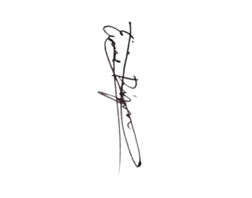SK Chairperson

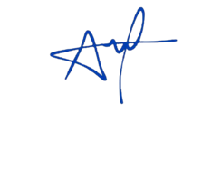

**HON. PAUL C. ALFONSO HON. ERVIE R. DIZON**

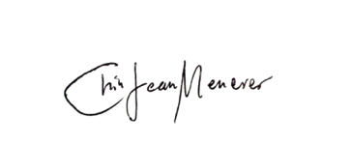SK Kagawad SK Kagawad



**HON. ANGELO F. UMALI HON. CHIN JEAN M. MENESES**

SK Kagawad SK Kagawad

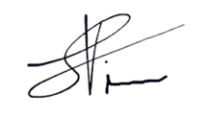

**HON. IAN JASPER C. VILLARICO HON. MICHAELA LORINE R. AMPARO**

SK Kagawad SK Kagawad

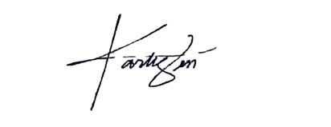

**HON. KAREN B. BAUTISTA**

SK Kagawad